
Year 9

Mini Test 4

Geometry
Total Marks: / 34
Name: ______________________ Total Time: 30 minutes

Notes Pages and Calculators allowed
Question 1 15 marks

Prove that the following triangles are congruent:
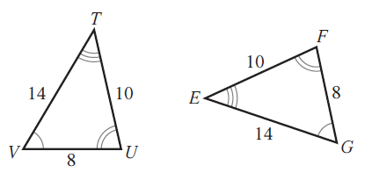
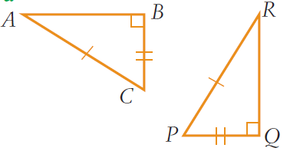
Remember to write down the rule e.g: AAA, SSS, SAS

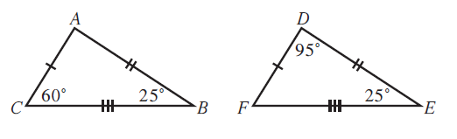

Question 2 10 marks

Determine if each of the following pairs of triangles are similar:
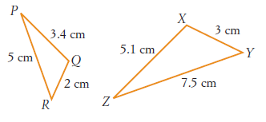
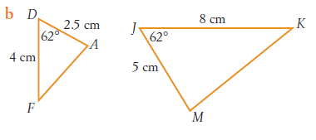
Remember to write down the rule e.g: AAA, SSS, SAS

Question 3 9 marks

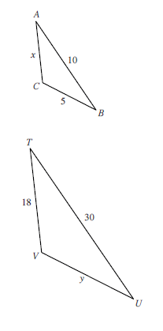
- Find the unknown side for the following similar triangles:

- Tonya is 1.3 meters tall. She stands 7 meters in front of a tree and casts a shadow 1.8 meters long. How tall is the tree?
